DIVIDING PERENNIALS:

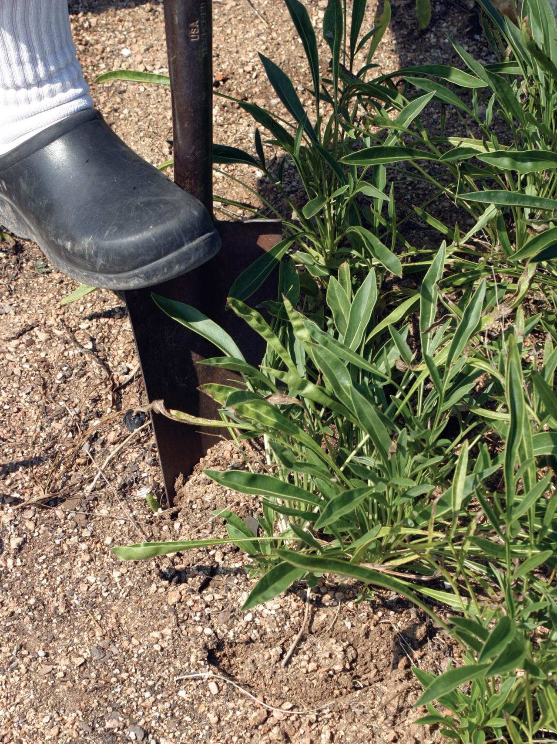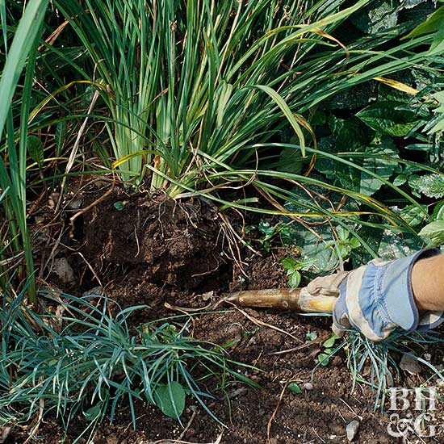

**TO DIG:**

**SHOVEL GOES STRAIGHT DOWN BESIDE ROOT BALL,**

**ON AT LEAST TWO SIDES**

**TO LIFT:**

**USE SHOVEL UNDER**

**THE ROOT BALL, TO LEVER IT OUT**

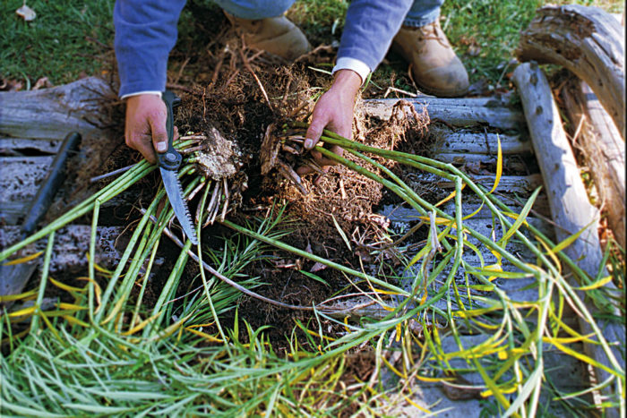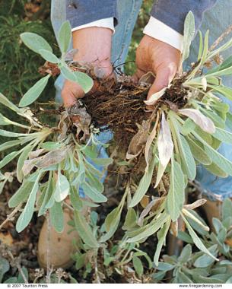

**TO DIVIDE THICK ROOTS:**

**INSERT SHOVEL STRAIGHT DOWN THROGH ROOT BALL, BRUTE FORCE.**

**SMALLLER ROOT MASS:**

**SOME CAN BE PULLED GENTLY APART**

**CORRCT POTTING:**

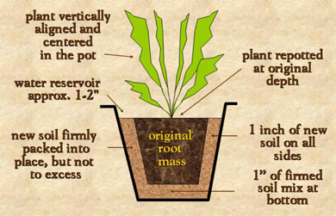

**THE CORRECT POT SIZE**

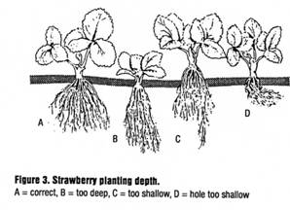

**NOT TOO HIGH, NOT TOO LOW, NOT CROOKED…JUST RIGHT!**

MLMCGUIRE, APRIL 2019